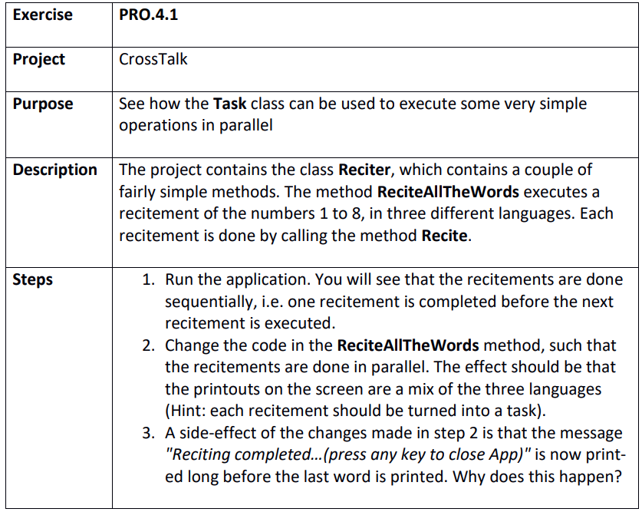

Step 1
C:\Git\OOProg25\Chap\Prog04\MySolution\PRO.4.1 - CrossTalk\CrossTalk\CrossTalk.sln

Step 2
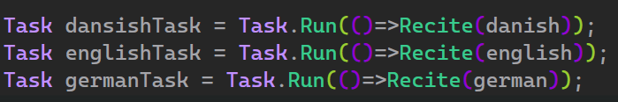

Step 3

